BLM 2
Bell Horses Student Solfège Chart

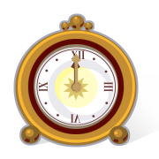so | so | so | so | so | so | so
so | so | so | so | so | so | so
mi | mi | mi | mi | mi | mi | mi
mi | mi | mi | mi | mi | mi | mi
la | la | la | la | la | la | la
la | la | la | la | la | la | la

la
so
mi
Copy the chart and the clock cards. Cut out the cards. Place cards on the staff to show the pattern of pitches in the song. Teacher Note: Enlarge the page; keep the cards and the staff in baggies so they can be used for any so-mi-la songs!

Create your own melodic patterns on the 3-line staff. Sing your patterns with hand signs. Share with a partner.

