Teacher Resource 2

FLAMENCO TECHNIQUE RESOURCE

LESSON #1

RESQUEADO AND RETURN STRUM
MUTED STRINGS: In order to focus on the right hand technique involved in this strum, lightly wrap the left hand and fingers around the neck and strings so the strings are muted (no pitch). Practice slowly while focusing on utilizing the correct technique. Only when the strum is evenly and consistently played, proceed using an E chord.

RESQUEADO STRUM: Step 1: Anchor p (thumb) on 6th string or sound board of guitar.
Step 2: Rapidly, and with an accent, flick/fan the remaining fingers in following sequence : a m i across the strings while maintaining the thumb anchor.
RESQUEADO NOTATION
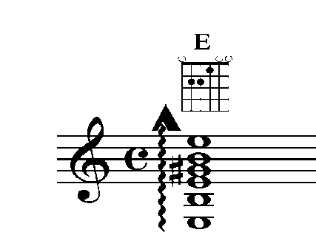
RETURN STRUM: Continue strumming pattern using up and down stroke with only
the i finger.
RESQUEADO & RETURN STRUM NOTATION
