Teacher Resource 3

FLAMENCO TECHNIQUE LESSON #2
SHEET 1:
RESQUEADO STRUM: Step 1: anchor p (thumb) on 6th strong or sound board of guitar
Step 2: rapidly, and with an accent, flick/fan the remaining fingers in following sequence : a m i across the strings while maintain the thumb anchor
RESQUEADO NOTATION
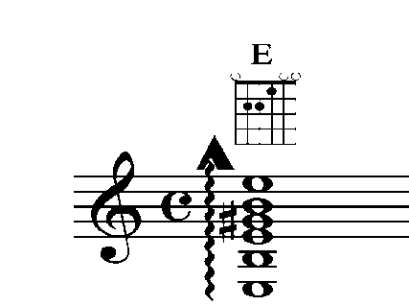
RETURNING STROKE: continue strumming pattern using up and down stroke with only the i finger
RESQUEADO & RETURNING STROKE NOTATION
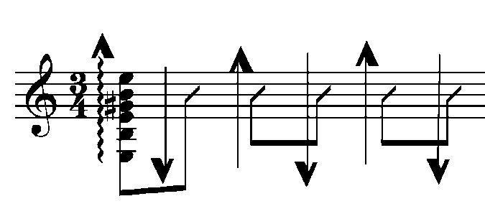
SOLERAS PROGRESSION #1
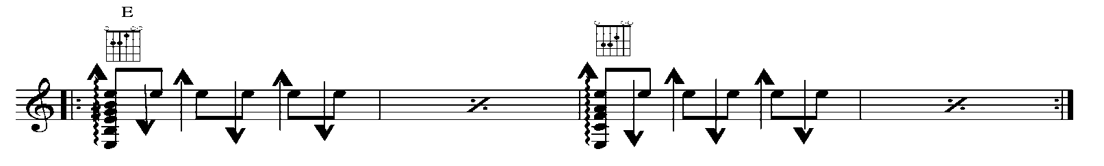
E SHAPE MOVED UP THE FRETBOARD ONE FRET

