Teacher Resource 4

FLAMENCO TECHNIQUE LESSON #2
SOLERAS PROGRESSION #1
In this progression we begin with the usual E chord in the first two measures. In the following two measures, simply slide that same E shape up one fret without lifting the fingers off the strings. When you get to the repeat sign, slide the shape back to its original position, again without lifting the fingers from the strings.
NOTE: This “new” chord has not been named as it could be called many different things depending on its function within the piece. Can you come up with two different names for this chord?
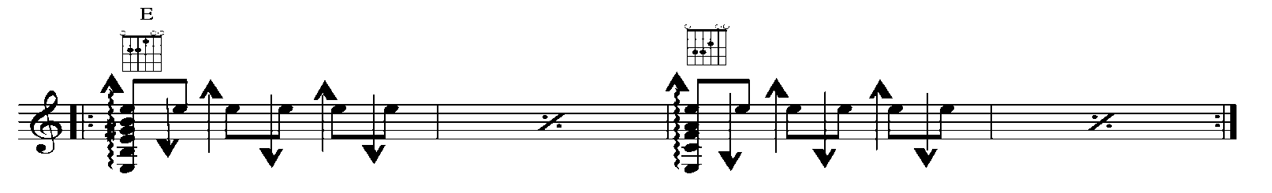

SOLERAS PROGRESSION #2
Soleras Progression #2 utilizes the same technique and rhythm structure as Soleras Progression #1. In this example the chords change every 2 measures. When you feel comfortable try switching chords every measure.
