BLM 6
FLAMENCO GUITAR DUET COMPOSITION – LESSON 3
Each student will complete their own original composition based on the instructions provided. The partner’s job is to: a) accompany the composer; and b) provide peer feedback during The Creative Process.
STEP 1: Insert your version/variation of Soleras Progression #2 into the staff for Guitar 2 using resqueado and returning strokes. You may use your choice of time signature and tempo. Be sure to utilize correct notation. You may add more measures if required.
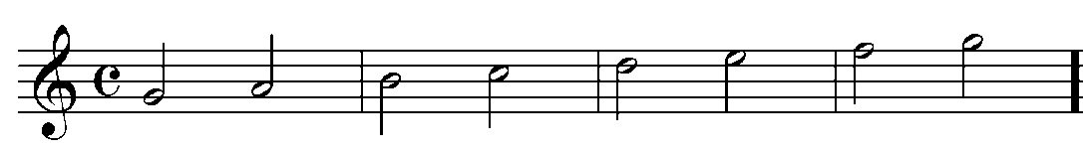STEP 2: In the staff for Guitar 1, write a melody to be played with alternating i m Tirando (free) strokes using only the following notes: one octave G (open 3rd string) to G (3rd fret 1st string)
