Teacher Resource 10
FLAMENCO TECHNIQUE LESSON 3
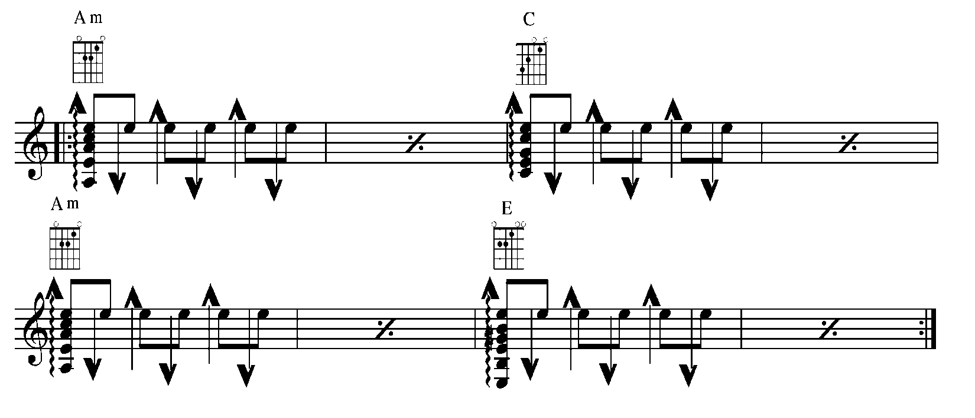
SOLERAS PROGRESSION #2

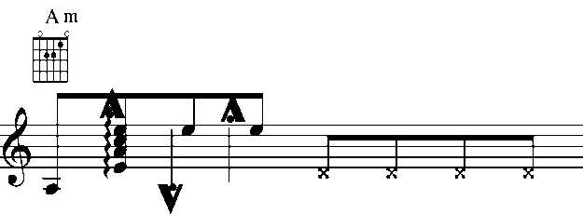
GOLPE: Tap soundboard with i m or a

TIRANDO: Like the “Free Stroke” in the classical style, this is used for single note melodic lines. It is played with alternating i m strokes. Play the following scale using the Tirando stroke.
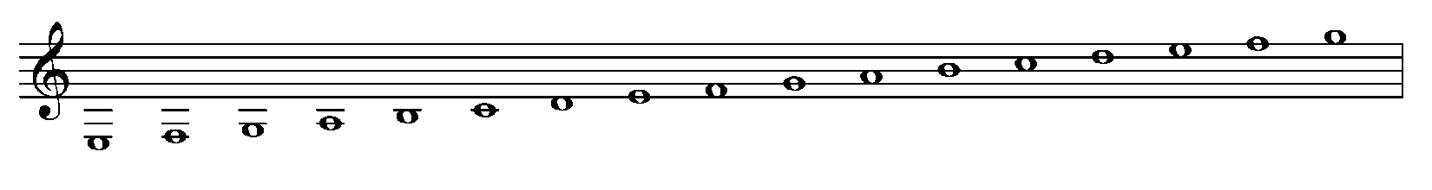
E PHYRGIAN MODE (SCALE) (1st position):

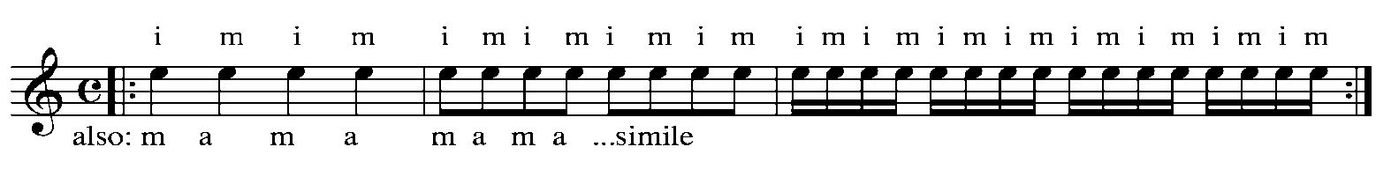
TREMELO (Exercise 1) using rapidly alternating Tirando (free) strokes, play the melody the style of Cante will determine the choice of tremelo.

TREMELO (Exercise #2)

