Teacher Resource 11
FLAMENCO TECHNIQUE LESSON 4

APOYENDO (REST) STROKE – p
Stylistically, the Apoyendo- or rest stroke – played with the thumb – p - is most often used in melodic phrases which occur on strings 6, 5, and 4. In this technique, the thumb plays the note and immediately comes to rest on the adjacent string. Below is the E Phyrgian scale as it occurs in first position on strings 6, 5, and 4. Practice this slowly before attempting to build speed. Apply the Apoyendo p stroke in appropriate places in some of your other repertoire.
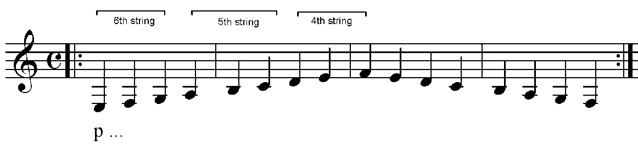
APOYENDO (REST) STROKE – i m
Stylistically, the Apoyendo - or rest stroke – played with i m - is most often used in melodic phrases which occur on strings 1, 2, and 3. In this technique, i and m alternate playing and immediately come to rest on the adjacent string. Below is the E Phyrgian scale as it occurs in first position on strings 3, 2, and 1. Practice this slowly before attempting to build speed. Apply the Apoyendo alternating i m strokes in appropriate places in some of your other repertoire.
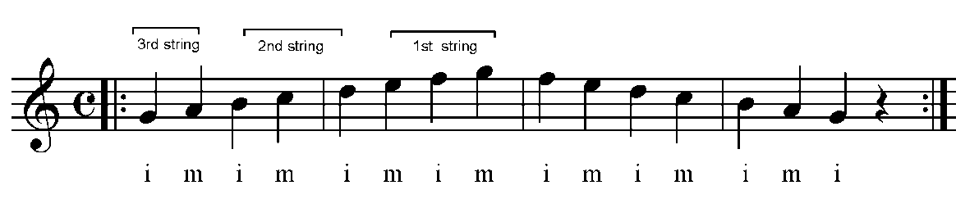

E PHYRGIAN MODE (SCALE) (1st position): Below is the entire E Phyrgian scale in first position. Practice this scale ascending and descending using the appropriate Apoyendo technique with the correct fingers.
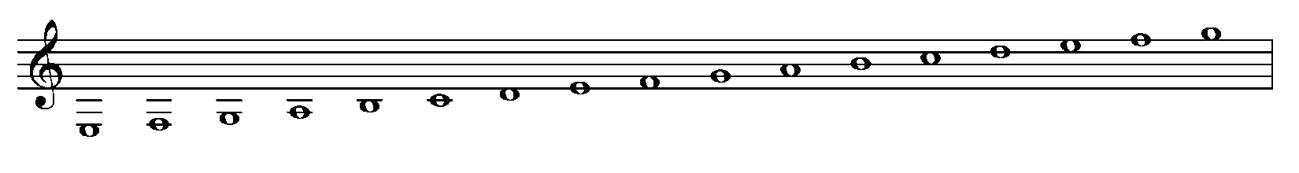

NOTE: There is no formal notation to indicate the Apoyendo stroke. Occasionally, some editors may include the term or fingering symbol as a suggestion, but, more often, it is left to the individual player to make an artistic choice based on the stylistic norms.

