BLM 2
CARULLI WALTZ Lesson 1 of 3
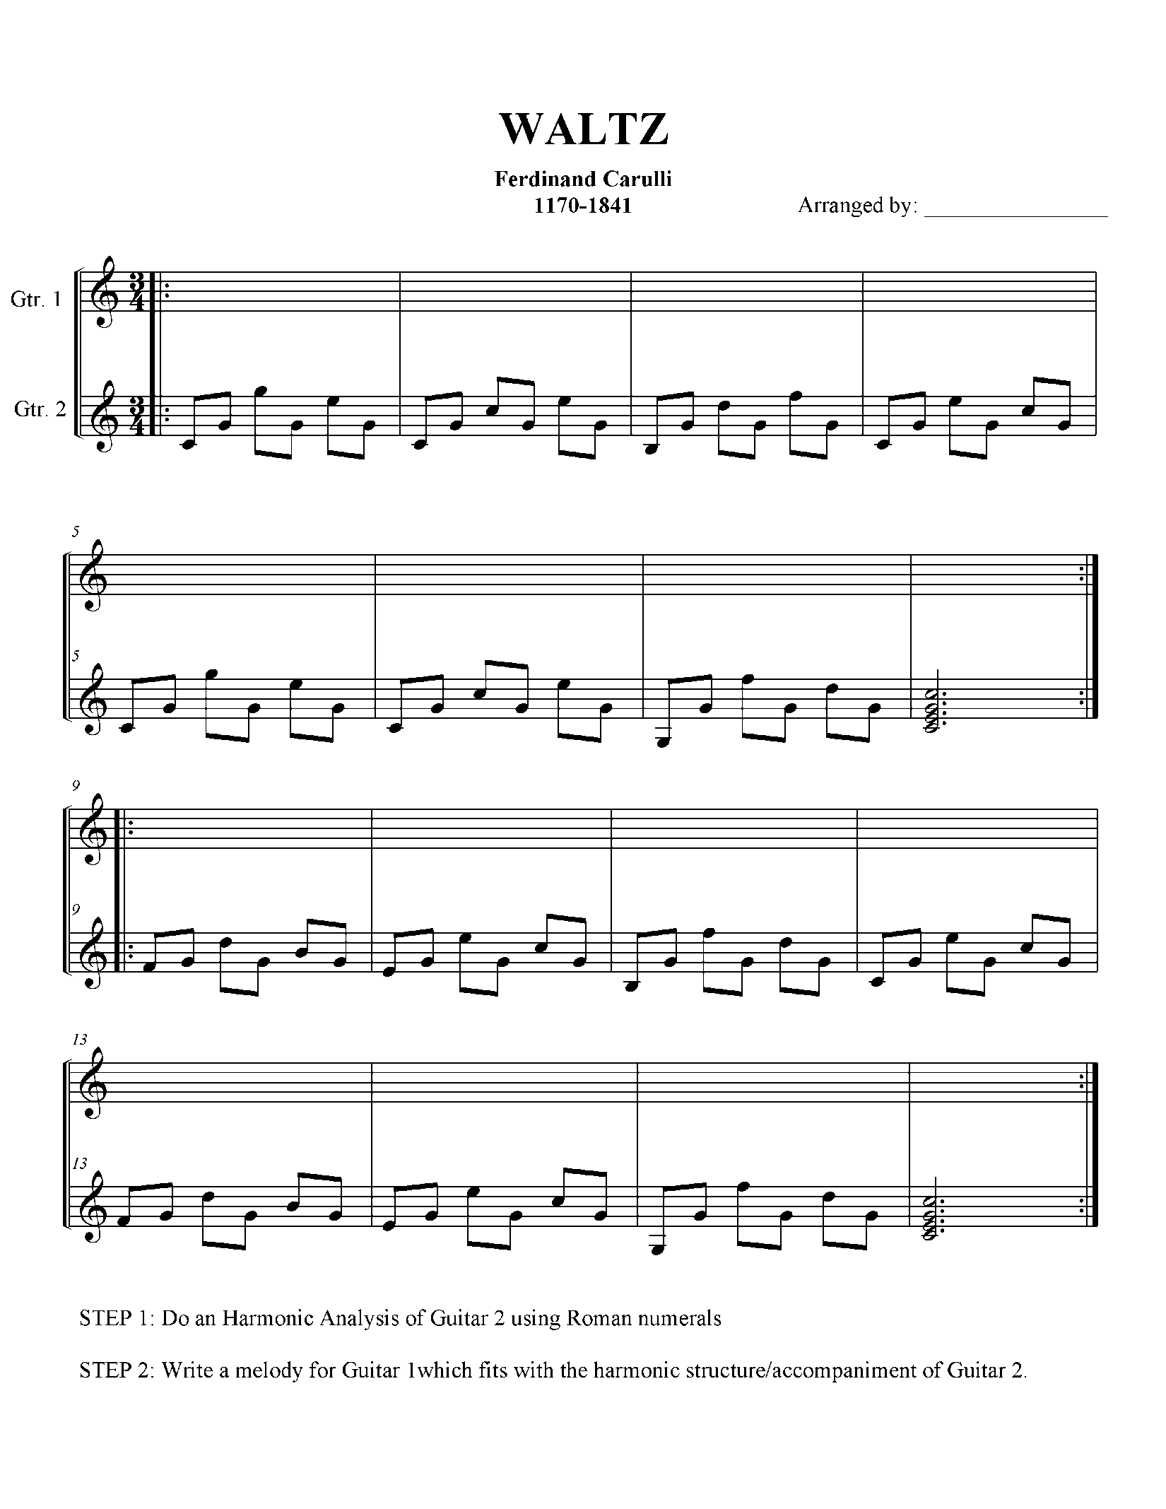
1770 - 1841

