Teachers, before you copy this booklet for your students...
⬰ Have you read the GPS Overview?
⬰ Have you taught these students before? If not, please take the time to work with your students to determine their strengths and needs before deciding which tasks will be appropriate...
⬰ Have you gone through the appropriate start up steps with your students? For example; the basics on putting together their instrument, care and maintenance of their instrument, posture and breathing.
⬰ If you have taught these students before...Go through the entire program task-by-task to confirm that the sequence and challenge level of the tasks, is appropriate.
⬰ Refer to the Q and A section of the GPS Overview.
⬰ Do you need to reduce the number of tasks...How will you need to change the evaluation by term?
⬰ If you have questions, please contact:
Sarah Arcand: sarahwylie@hotmail.com

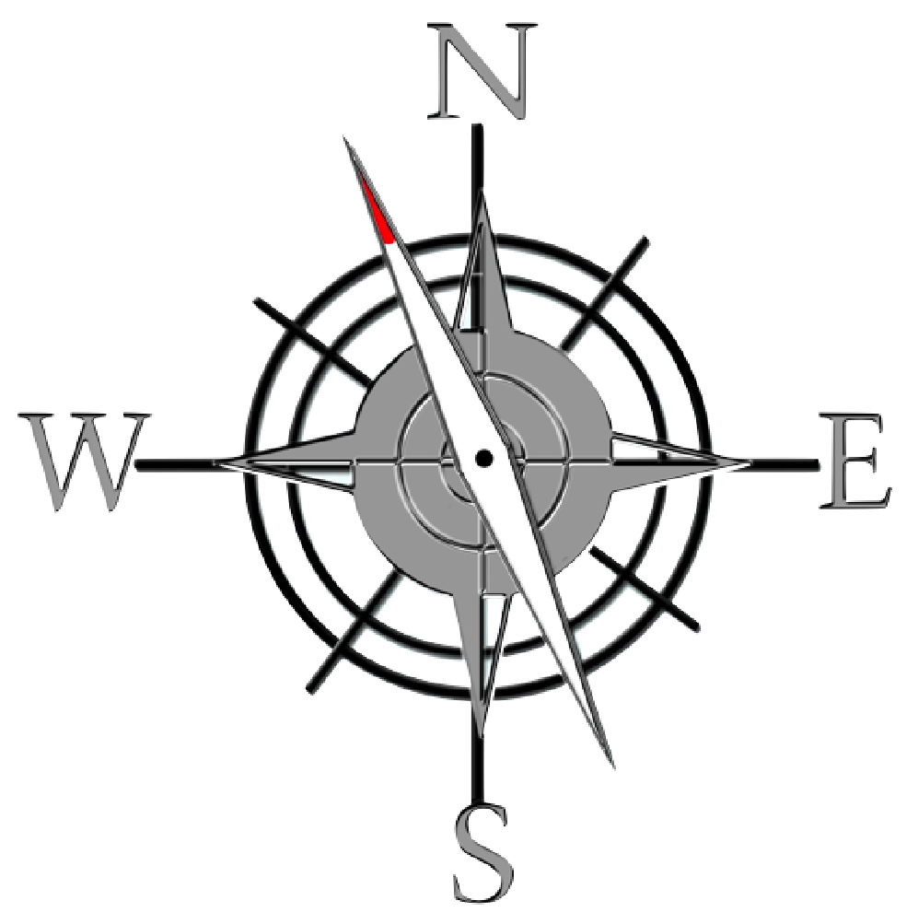

GPS Task Evaluation Chart
TEACHER REFERENCE
Year One Band
This is assuming that this program starts in late October early November

Tasks  (Completion of “X” task number equals “Y” %) | Term 1 (September to February) | Term 2 (February to June)
1 | 52% | 32%(R)
2 | 55% | 35%(R)
3 | 58% | 38%(R)
4 | 62% | 42%(R)
5 | 65% | 45%(R)
6 | 68% | 48%(R)
7 | 72% | 52%
8 (taught to) | 75% | 55%
9 | 78% | 58%
10 | 82% | 62%
11 | 88% | 65%
12 | 92% | 68%
13 | 98% | 72%
14 (taught to) | 100% | 75%
15 |  | 78%
16 |  | 82%
17 |  | 88%
18 |  | 92%
19 |  | 98%
20 |  | 100%

Tasks 15 to 20 serve as extensions and culminating activities which encompass the concepts learned or introduced in Tasks 1 to 14. What you must teach are the 14 tasks by the end of the year.
GPS
(Grade Performance Steps)

The Road to Musical Success!

Intermediate Band Performance Tasks
YEAR ONE

Trumpet
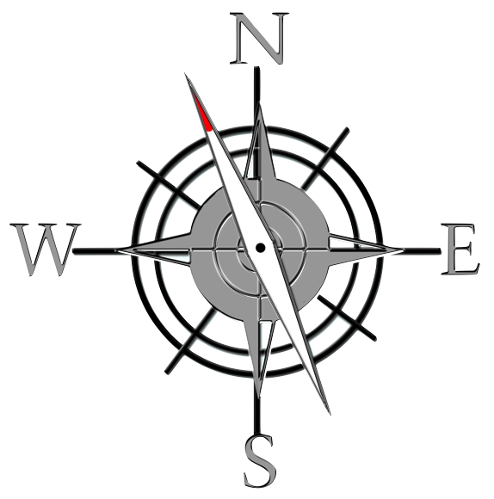

Ontario Music Educators’ Association

GPS Task STUDENT Evaluation Chart
Year One Band

In order to be successful this year, you will need to plan out how many tasks you think you can complete, and the mark you want to receive for performing on your instrument! Below is a summary of the number of tasks per term, and the mark you will receive for the tasks you complete:

Tasks  (Completion of “X” task number equals “Y” %) | Term 1 (September to February) | Term 2 (February to June)
1 | 52% | 32%(R)
2 | 55% | 35%(R)
3 | 58% | 38%(R)
4 | 62% | 42%(R)
5 | 65% | 45%(R)
6 | 68% | 48%(R)
7 | 72% | 52%
8 | 75% | 55%
9 | 78% | 58%
10 | 82% | 62%
11 | 88% | 65%
12 | 92% | 68%
13 | 98% | 72%
14 | 100% | 75%
15 |  | 78%
16 |  | 82%
17 |  | 88%
18 |  | 92%
19 |  | 98%
20 |  | 100%

Performance is just one part of your Music evaluation this year. Your teacher will let you know what the other aspects of your program are on your two summative report cards.

Remember that with the GPS tasks:
- We will be learning concepts introduced as a class.
- You will have time in class to practice and receive feedback from your teacher and classmates.
- You will have multiple opportunities to demonstrate these tasks.
- You need to demonstrate at least a Level 3 performance (your teacher will talk with you about what a Level 3 demonstration would sound like).
- In order to be successful, you will need to work independently in class, and outside of class time (recess, lunch, after school and practice at home).

YEAR ONE – INTERMEDIATE BAND
GPS PROGRAM

1. LET’S HEAR YOU! FOCUS: PITCH
Wind Instruments and Mallets

Winds: Task 1

LEARNING GOAL (Wind Instruments): You will play a long tone for 10 seconds (5 for flute and tuba) on your mouthpiece or head joint.

MINDS ON! How long you can conserve your breath? Why do you think that this might be important as a wind player? How much air can your lungs hold? Professional athletes must train to improve their stamina, so must musicians!

ACTION! In order to be successful with this task, you will need to:
- Take in a deep (low) breath.
- Consistently let this air out of your mouth with a correct playing embouchure and posture over 10 seconds (5 for flute and tuba).
- Conserve air and pace yourself…This will require practice.
- Apply this process using your mouthpiece or head joint.

CONSOLIDATION! In order to move on to the next task, you will need to perform you’re long tone for 10 seconds (5 for flute and tuba) on your mouthpiece or head joint.

2. FEEL THE BEAT FOCUS: BEAT
Wind Instruments and Snare Drum

Winds: Task 2

LEARNING GOAL (Wind Instruments): Moving your toe inside your shoe, perform either the 1st, 3rd or 5th note of B Flat Concert for 16 quarter notes. Wind instruments may breathe as needed. Your teacher will set the tempo.

MINDS ON! Why is it important to feel the beat while playing your instrument? Does the beat change in music or is it the tempo that changes?

ACTION! In order to be successful with this task, you will need to:
- Practice the coordination of playing your instrument while moving just your toe – NOT your entire foot.
- Ask your teacher what note they would like you to play and what the tempo of this task is.
- Be sure to be aware of the steady beat and counting to 16.

CONSOLIDATION: In order to move to the next task, for your teacher you will need to play the previously decided note for 16 quarter notes while moving your toe inside your shoe.

3. START PUTTING IT TOGETHER! FOCUS: BEAT/RHYTHM
Wind Instruments and Snare Drum

LEARNING GOAL (Winds): In this task you will demonstrate your understanding of whole notes, half notes and quarter notes while playing “Hot Cross Buns”. The following piece of music includes the first three notes of the B Flat Concert Scale

MINDS ON! When encountering a new song, why is it important to first scan the entire piece before playing? Don’t forget to maintain good posture and breathing while moving on to more difficult music.

ACTION! In order to be successful with this task, you will need to:

- Scan the music for upcoming rhythms and notes, which may need extra practice.
- Scan the music for patterns.
- Demonstrate good posture and breathing.

CONSOLIDATION: In order to move to the next task, you must perform Hot Cross Buns for your teacher.

Hot Cross Buns
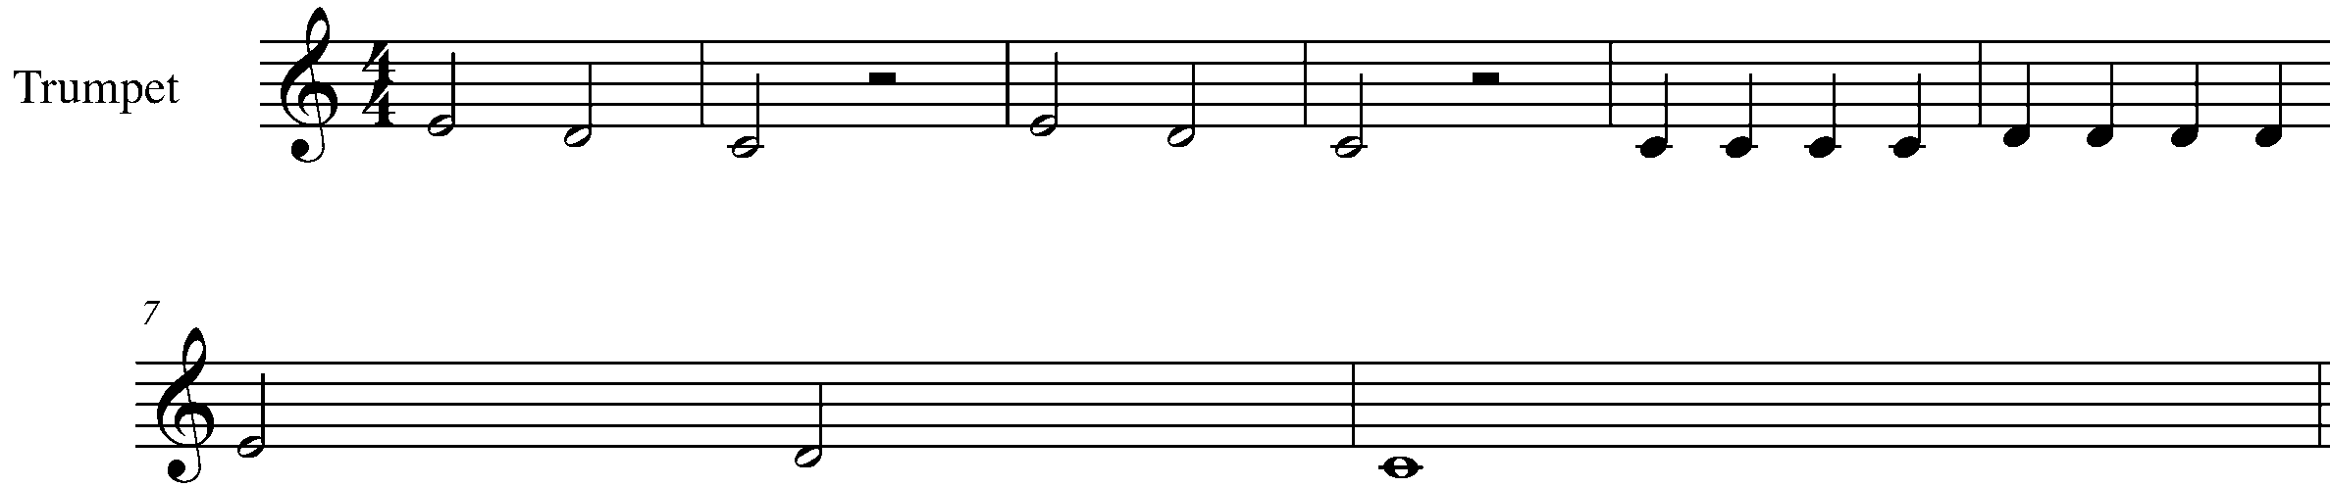

4. THE GREAT COMPOSITION BEGINS! FOCUS: NOTATION
Wind Instruments and Mallets

LEARNING GOAL: You are going to start setting up your own composition. This composition will be set up in stages throughout this GPS program.

MINDS ON! Where does the clef sit on the staff? Where does the time signature go? Do you need to insert any flats or sharps so that your composition will be in the key of concert B Flat?

ACTION! Before you begin this task you need to:

- Look at other samples of music and determine what symbols are needed to set up a piece of music.
- Practice drawing your appropriate clef on the staff.
- USE A PENCIL – you may need to move things around when you enter the notes.

In order to move to the next task you need to place the following items on the above task and have it checked by your teacher

THE BLANK STAFF IS FOUND ON THE FOLLOWING PAGE

- A treble or bass clef (the one that is appropriate for your instrument).
- A 4/4 time signature.
- The appropriate key signature for your instrument (Concert B Flat).
- Create 8 empty bars of music – you will put in the notes and rhythms later.
- A double bar line at the end of the piece.

____________________________________________________________________________________________________________________________________________________________________________________________________________________________________________________________________________________________________________________________________________________________________________________________________________________________________

____________________________________________________________________________________________________________________________________________________________________________________________________________________________________________________________________________________________________________________________________________________________________________________________________________________________________

CONSOLIDATION: Show this task for your teacher to receive feedback.

5. SKIPPING TO SO-MI (5th note to 3rd note) FOCUS: PITCH
Wind Instruments and Mallets

LEARNING GOAL: To this point many of your notes have been in steps. This task will focus on skips between familiar notes.

MINDS ON! Being prepared will be your best asset when completing this task. Always look ahead in your music so that you know what notes, rhythms and challenges are coming up. Why is it more difficult to play notes that are skips then notes that are in a step like pattern?

ACTION! In order to be successful with this task, you will need to:

- Practice having a consistent air flow (winds) between two notes that are not beside each other (a skip).
- Have a balance of sound on repeated notes – don’t let the notes be different dynamic levels.
- Demonstrate good posture, good breathing and proper technique.

CONSOLIDATION: In order to move onto the next tasks, you must perform Rain, Rain Go Away for your teacher – found on the following page.

Rain, Rain Go Away

CONGRATULATIONS! YOU HAVE REACHED YOUR FIRST GPS MARKER – NORTH!

ASK YOUR TEACHER HOW YOUR ARE TO ACKNOWLEDGE THIS ACCOMPLISHMENT ON YOUR GPS TASK TRACKER!

6. THE FIRST 5 NOTES FOCUS: PITCH/RHYTHM
Wind Instruments and Snare Drum/Bass Drum/Kit

Winds: Task 6

LEARNING GOAL (Winds): This task will have you demonstrate your understanding of the first 5 notes of the B Flat major scale.

MINDS ON! Why might you want to clap out the rhythm to yourself before playing through this piece? Make sure that you continue moving your toe inside your shoe while practicing this song.

ACTION! In order to be successful with this task, you will need to:

- Have a consistent air speed for every note performed.
- Demonstrate accurate rhythms and a consistent tempo.
- Demonstrate good posture.

CONSOLIDATION: In order to complete this task you must perform the following Task 6 song for your teacher AND complete the following self reflection.

SELF-REFLECTION: What I found challenging about this task was…
____________________________________________________________________________________________________________________________________________

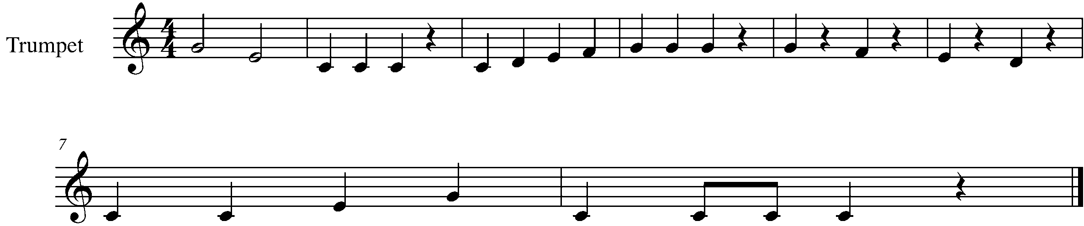

7. FEELING THE BLUES FOCUS: FORM
Wind Instruments and Mallets

LEARNING GOAL: This task will teach you how to perform a 12 bars blues progression in the key of B Flat Major.

MINDS ON! Why are we learning the 12 bar blues progression? Why are the blues important to the evolution of music? All things have history – think about how the blues fits into the history of music.

ACTION! In order to be successful with this task, you will need to:

- Scan the music for Task 7, found on the next page.
- Understand that the following series of notes creates a 12 bar blues progression.
- Be able to demonstrate an understanding of the notes and the rhythms within the progression.

CONSOLIDATION: In order to complete this task, for year teacher you must perform the 12 bars blues progression with accurate rhythm and pitch.

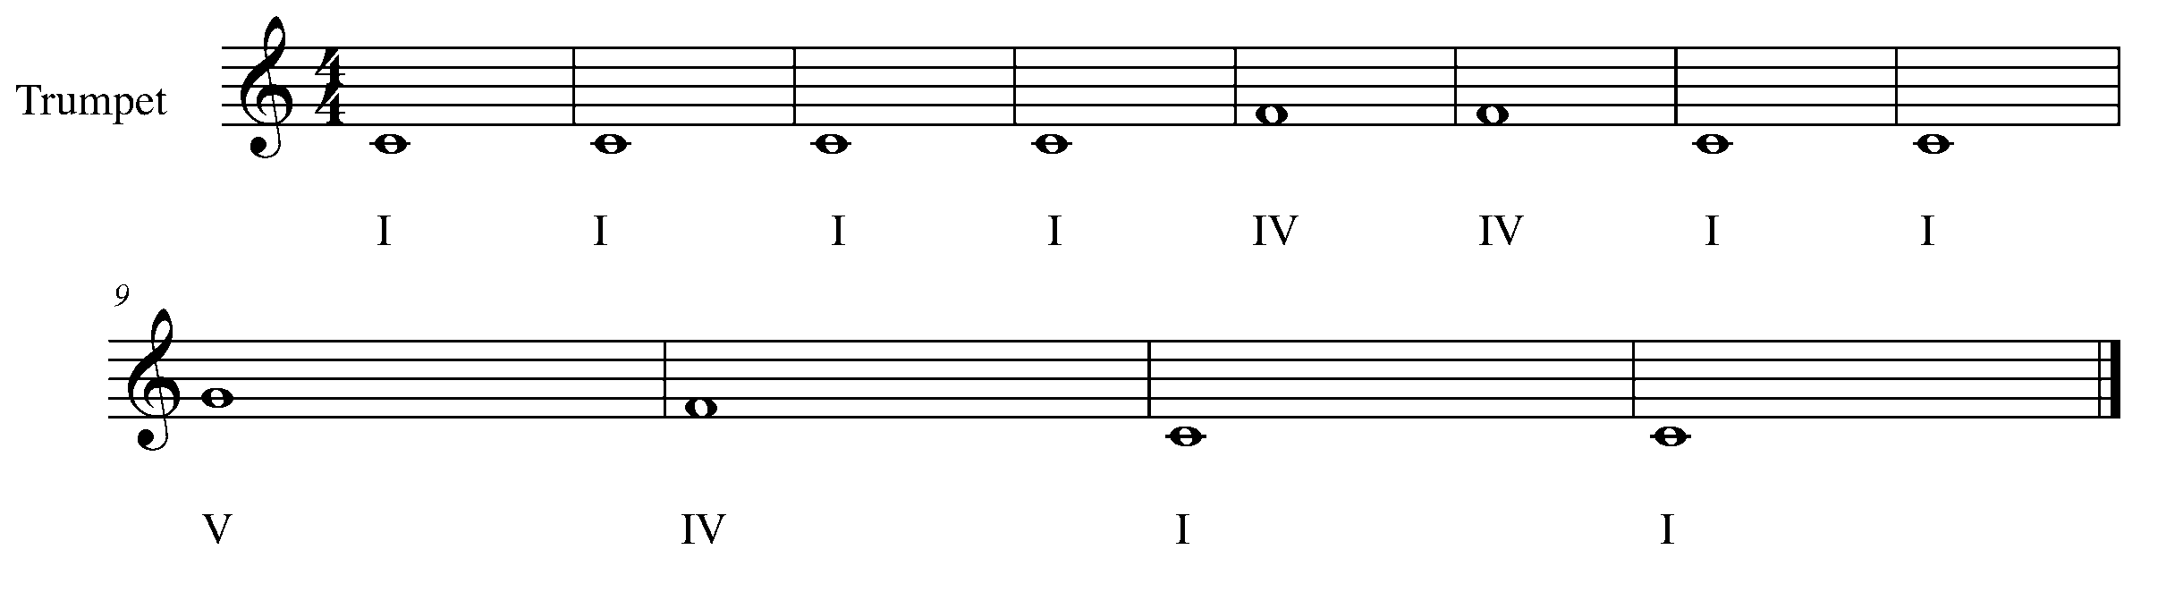

8. THE SLUR AND THE ROLL! FOCUS: EXPRESSIVE CONTROLS
Wind Instruments and Snare Drum

Winds: Task 8

LEARNING GOAL: The purpose of this task is to demonstrate your ability to slur on a wind instrument with a consistent sound and air flow.

MINDS ON! How to you execute a slur? How do you articulate the first note of a slur? What does your air and your fingers need to do in order to correctly play a slur. Trombone Players: How do you play slurs differently from all the other wind instruments? Why?

ACTION! In order to be successful with this task, you will need to:

- Demonstrate an understanding of how to perform a slur on your instrument.
- Start the note at the beginning of a slur with a clear tonguing sound.
- Connect all the notes in the slur with an even airflow and smooth fingers.

CONSOLIDATION: In order to complete this task, you must perform the following song for your teacher, demonstrating your understanding of the slur.

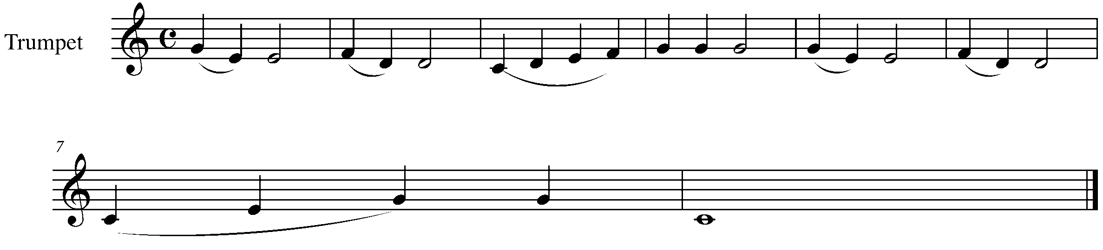

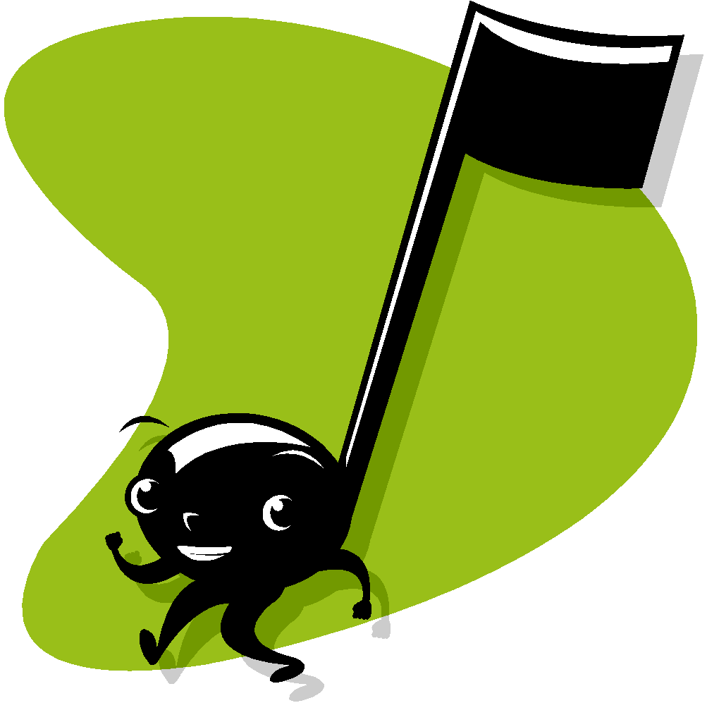

9. “TIE” ING IT TOGETHER FOCUS: RHYTHM
Wind Instruments and Mallets

LEARNING GOALS: The purpose of this task is to demonstrate an understanding of how a tie functions within a piece of music.

MINDS ON! If a tie adds the rhythm of notes together, why would you not just merge the notes together to be one? Sometimes we add symbols into music for a reason – why do you think the tie needs to exist?

ACTION! In order to be successful with this task, you will need to:

- Understand what is the function of a tie is and how it affects the music you are performing.
- Demonstrate good posture, accurate pitch and rhythms throughout the piece of music below.

CONSOLIDATION: In order to complete this task, for your teacher you must perform the following song demonstrating an understanding of how the tie is performed within a piece of music.

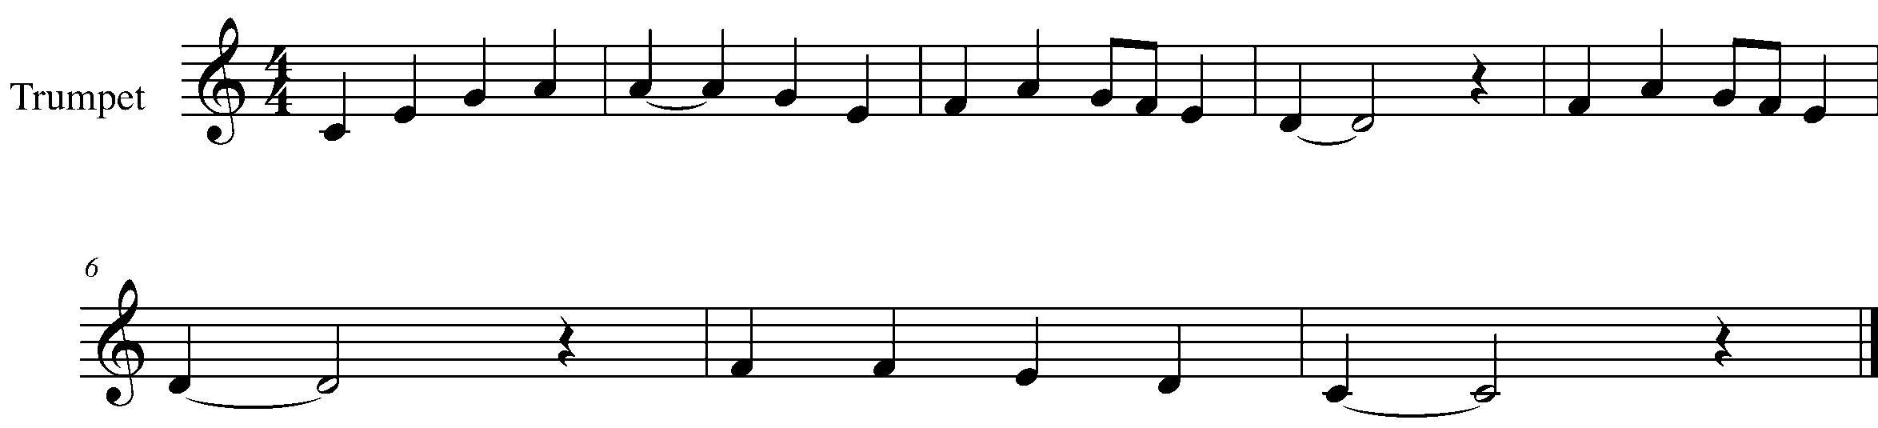

10. CONTROL IT!! FOCUS: PITCH/EXPRESSIVE CONTROL
Wind Instruments and Snare Drum

Winds: Task 10

LEARNING GOAL (Winds): The purpose of this task is to play a long tone on the 5th note of the B flat concert scale for 15 seconds (10 for flute and tuba).

MINDS ON! How has your stamina improved since task 1? Think about how your posture affects your ability to inhale and demonstrate control of your air stream.

ACTION! In order to be successful with this task, you will need to:

- Take in a deep (low) breath.
- Consistently let this air out of your mouth with correct embouchure and posture over 15 seconds (10 for flute and tuba).
- Conserve air and pace yourself…This will require practice.
- Apply this while playing the 5th note of the B Flat concert scale.

CONSOLIDATION: In order to move on to the next task, you will need to perform you’re long tone for 15 seconds (10 for flute and tuba) on your mouthpiece or head joint.

CONGRATULATIONS! YOU HAVE REACHED THE SECOND GPS MARKER -EAST!

YOU ARE HALFWAY TO THE FINAL GPS DESTINATION
DON’T FORGET TO FILL IN YOUR TASK TRACKER!

11. DOT, DASH and ACCENT FOCUS: EXPRESSIVE CONTROLS
. - > Wind Instruments and Snare Drum

LEARNING GOALS: The purpose of this task is to recognize, and on your instrument, perform three different articulations.

- The “dot” below or above a note represents a staccato marking (short).
- The “dash” below or above a note represents a legato method of tonguing (longer).
- The “accent” below or above a note represents the strong emphasis of a note (attack).

MINDS ON! Hi. Hiiiiiiii! Hi!!!! How does punctuation change the way that we say a word? Articulation markings in music communicate how to “say” a note. How should the dot, dash and/or accent sound different from one another?
ACTION! In order to be successful with this task, you will need to:

- Listen to yourself playing the difference between the dot, dash and the accent.
- Demonstrate good breathing, expressive control and posture.
- Use the appropriate sticking pattern (percussion)

CONSOLIDATION: In order to complete this task, for year teacher you must perform the dot, dash, accent exercise for your teacher and receive feedback.

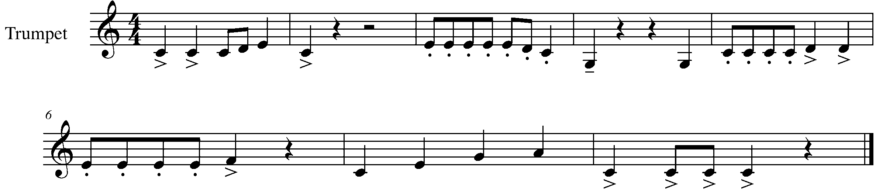

12. THE GREAT COMPOSITION CONTINUES FOCUS: NOTATION
Wind Instruments and Mallets

LEARNING GOAL: The purpose of this task is to create 8 bars of a playable rhythm in 4/4 time. Use rhythms with which you are comfortable performing on your instrument.

MINDS ON! Why is it important that you are able to play the rhythm that you are writing? Although you may be aware of how to write more difficult rhythm patterns, it is important that you think out the execution of these rhythms.

ACTION! In order to be successful with this task, you will need to:

- Decide upon a variety of rhythms that you are able to play on your instrument.
- Create bars of rhythm with a 4/4 time signature and write it in the space provided.
- Make sure you use a pencil.
- YOU DO NOT NEED TO ADD PITCH TO THESE RHYTHMS (YET).

CONSOLDATION: In order to move on to the next task, you will need to complete 8 bars of rhythm in 4/4 time that you or any of your classmates could play. Once written, give this task to your teacher and receive feedback.
13. LOUD VS. SOFT FOCUS: DYNAMICS
Wind Instruments and Snare Drum/BD/Kit

LEARNING GOAL: The purpose of this task is to demonstrate your ability to control the volume level of your instrument.

MINDS ON! How does your posture, breath control and support relate to your ability to control the dynamics on your instrument? How does the dynamic level of your voice help you to communicate your different thoughts? Are you able to communicate a variety of thoughts through dynamics on your instrument?

ACTION! In order to be successful with this task, you will need to:

- Practice performing a short, familiar passage at two different dynamic levels (forte and piano).
- Make sure that you are controlling your air flow, sticking strength and demonstrating good posture.
- Listen to yourself.

CONSOLIDATION: In order to move on to the next task, you will need to demonstrate your ability to perform the dynamics as indicated in the following piece of music.

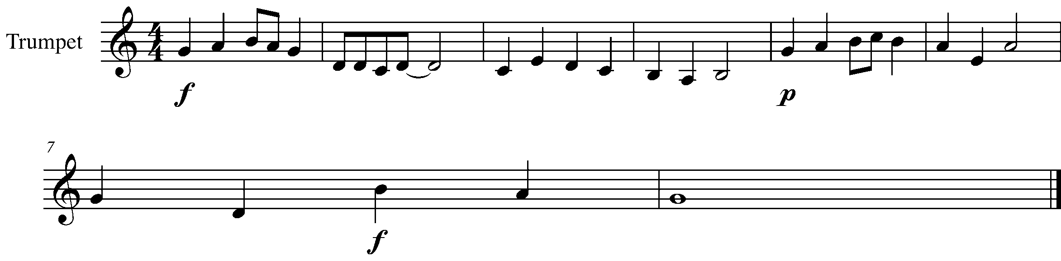

14. LEAPING LIZZARDS! FOCUS: PITCH
Wind Instruments and Mallets

LEARNING GOAL: The purpose of this task is to demonstrate your ability to play a variety of notes within an octave that move in skips and steps.

MINDS ON! How do you need to prepare differently for playing notes that are skips instead of steps? Just as walking and skipping uses similar muscles, they are not the same action and need to be prepared for differently.

ACTION! In order to be successful with this task, you will need to:

- Make sure that you have a consistent air flow between all notes, steps and skips.
- Try to balance the dynamic level of all notes by controlling your air flow or the way you strike the bars of your mallets. Make sure to use both of your hands on the mallets.
- Smartly choose where you breathe within the phrase. Taking in a big breath before the note to which you are leaping makes that note stick out. Continue taking in air at the appropriate place within the phrase.

CONSOLIDATION: In order to move on to the next task, you will need to perform, the following piece while demonstrating good balance and control of all the pitches.

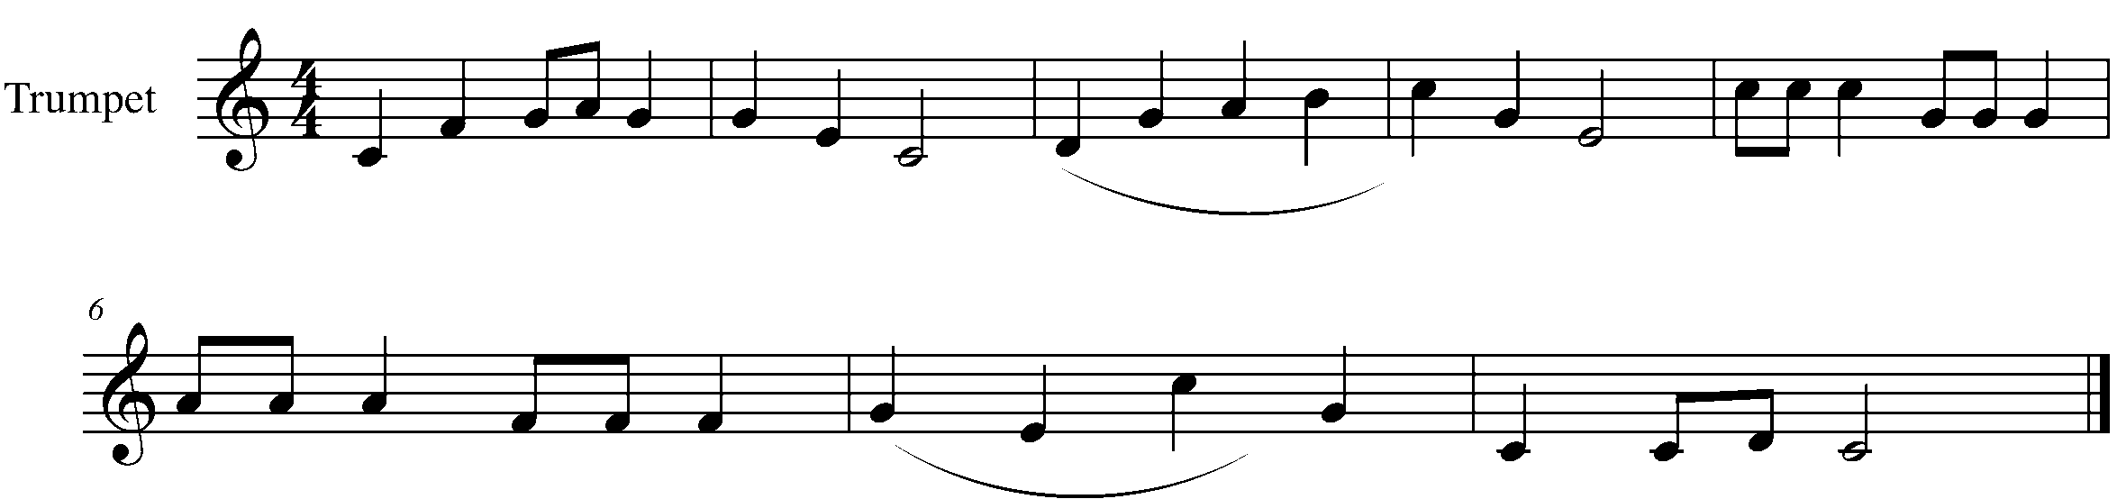

15. TRIADS: MAJOR AND MINOR FOCUS: PITCH
All

LEARNING GOAL: To be able to recognize and label the difference between a Major triad and a Minor triad in the indicated key.

POINT OF INFORMATION: A triad is a chord of three notes including the root note of the scale, the Major (+) or Minor (-) third of the scale and the perfect fifth (p5) note of the scale.

MINDS ON! Why is knowing the key signature of a scale important to this task? Seeing the difference between a major triad and a minor triad is the first step to being able to hear the difference.

ACTION! In order to be successful with this task, you will need to:

- Determine the Key signature of C Major and B Flat Major
- Determine what note is the Major 3rd and what note is the Minor 3rd in B Flat Major.
- Label the above triads as either Major or Minor.
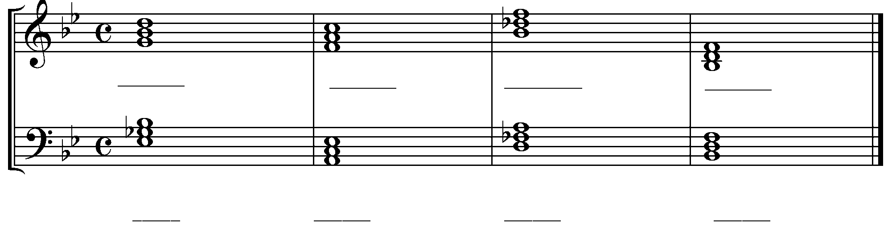
CONSOLIDATION: In order to move on to the next task, you will need to label the above triads as Major (+) or Minor (-). When complete, hand in to your teacher for evaluation.

CONGRATULATIONS! YOU HAVE REACHED THE THIRD GPS MARKER -SOUTH!

YOU ARE VERY CLOSE TO THE FINAL GPS DESTINATION
DON’T FORGET TO FILL IN YOUR TASK TRACKER!

16. BECOMING AN EIGHTH NOTE EXPERT FOCUS: RHYTHM
Wind Instruments and SD/BD/Kit

LEARNING GOAL: The purpose of this task is to perform a variety of articulations, while concentrating on the counting and accurate placement of eighth notes.

MINDS ON! Thinking through a song before you perform it can be a very important skill – why? Why is picking a tempo at which you can best perform eighth notes so important? What is a good way to count when playing eighth notes?

ACTION! In order to be successful with this task, you will need to:

- Identify the different articulation markings and practice how they each should sound.
- Pick a tempo in which you can consistently perform the above rhythm.
- Practice the above pattern, demonstrating your understanding of eighth notes and articulations.
CONSOLIDATION: In order to move on to the next task, you will need to demonstrate your understanding of eighth notes and a variety of articulations while performing, “Hey Diddle Diddle” for your teacher.

Hey Diddle Diddle

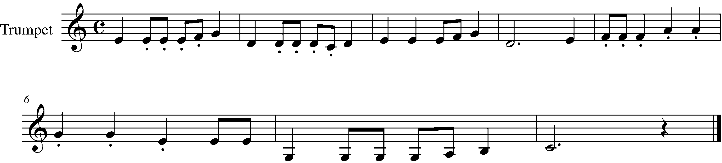

17. “PICKING – UP” A NEW SKILL FOCUS: RHYTHM
Wind Instruments and Snare Drum/BD/Kit

LEARNING GOAL: The purpose of this task is to understand and perform a song, which begins with a pickup note.

MINDS ON! When a piece of music is in 4/4 time, do some beats get a stronger pulse then others? If so, then how does a pickup note affect the “feel” of a piece?

ACTION! In order to be successful with this task, you will need to:

- Figure out on which beat the pickup note lies.
- Demonstrate an understanding of how the pickup note is performed considering breathing and the different stresses of each beat.

CONSOLIDATION: Perform the following task for your teacher to receive feedback.

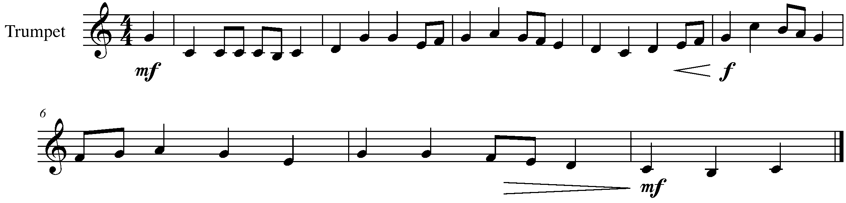

18. THE FINISHING TOUCHES FOCUS: NOTATION
Wind Instruments and Mallets

LEARNING GOAL: The purpose of this task is to add pitches and the finishing touches (dynamics, articulation, key signature) to your rhythmic composition created in two previous tasks.

MINDS ON! What are the common things you see when looking at printed music? What do you notice about the stem directions, the bar lines, the beginning and the end of the song etc.? Have you included all of these elements in your composition?

ACTION! In order to be successful with this task, you will need to:

- Use a PENCIL.
- Draw your instrument’s appropriate clef at the beginning of the provided staff.
- Pick the key in which you want to work – B Flat Concert would be a good choice but is not mandatory.
- Place the rhythm that you created in task 12 on staff – CAUTION: remember to use notes that you can play and a pattern that sounds like a melody. Don’t just put in random notes. HINT: Starting and ending on the first note of the scale will nicely frame the piece.
- Make sure that you can play what you have written. It’s not about difficulty; it’s about accuracy.
- Give your composition a title.

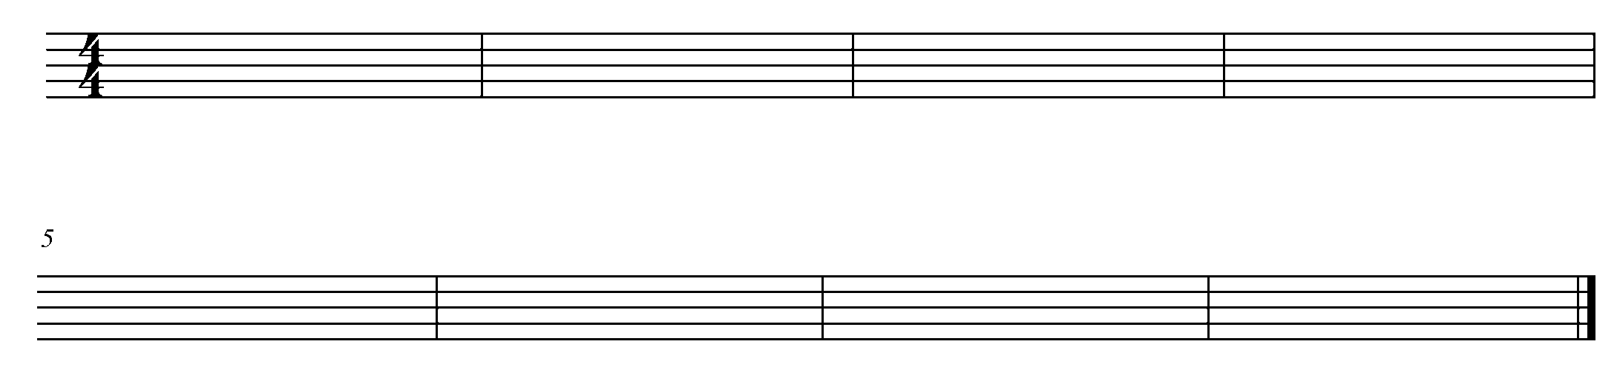

CONSOLIDATION: In order to move on to the next task you must, add the finishing touches and pitch to complete your composition. Once complete, have a classmate peer edit your composition with you. When the peer edit is complete, have your classmate sign the below statement:

I _____________________________ have peer edited my classmate’s
(Classmate’s name)
composition and to the best of my ability, explained and corrected WITH MY CLASSMATE, their composition.
___________________________________
(Classmate’s signature)

19. ALMOST THERE... FOCUS: EXPRESSIVE CONTROLS
Wind Instruments and Mallets

LEARNING GOAL: The purpose of this task is to perform your composition for your teacher.

MINDS ON! Think of the 3 musical “P’s” when preparing for your performance: POSTURE, PHRASING and PRACTICE!

ACTION! In order to be successful with this task, you will need to:

- Practice and prepare your composition to perform for your teacher.
- Don’t forget to apply all of your knowledge of the elements of music and performance while preparing for completion of this task.

CONSOLIDATION: Perform your composition for your teacher and receive feedback. Make any appropriate changes before performing it again in task 20.

20. FINALE! FOCUS: CULMINATING TASK
Wind Instruments and Mallets

LEARNING GOAL: The purpose of this task is to perform your composition for a small group or class as organized and supervised by your teacher.

MINDS ON! How are you going to apply the skills that you have developed up to this point? How will your confidence level, preparation and body posture affect your final performance?
ACTION! In order to be successful with this task, you will need to:

- Consider the feedback that you received in tasks 19 and 20 – apply this feed back to your performance.
- With your teacher, organize the time and group for which you will be performing.
- Practice all aspects of your performance: the introduction of your piece, your name, how you will sit or stand and the music.

CONSOLIDATION: Perform you composition for the assigned group or class while supervised by your teacher.

CONGRATULATIONS! YOU HAVE REACHED
YOUR DESTINATION!
THE FINAL WEST GPS MARKER.

DON’T FORGET TO FILL IN YOUR TASK TRACKER AND CELEBRATE YOUR ACCOMPLISHMENTS!

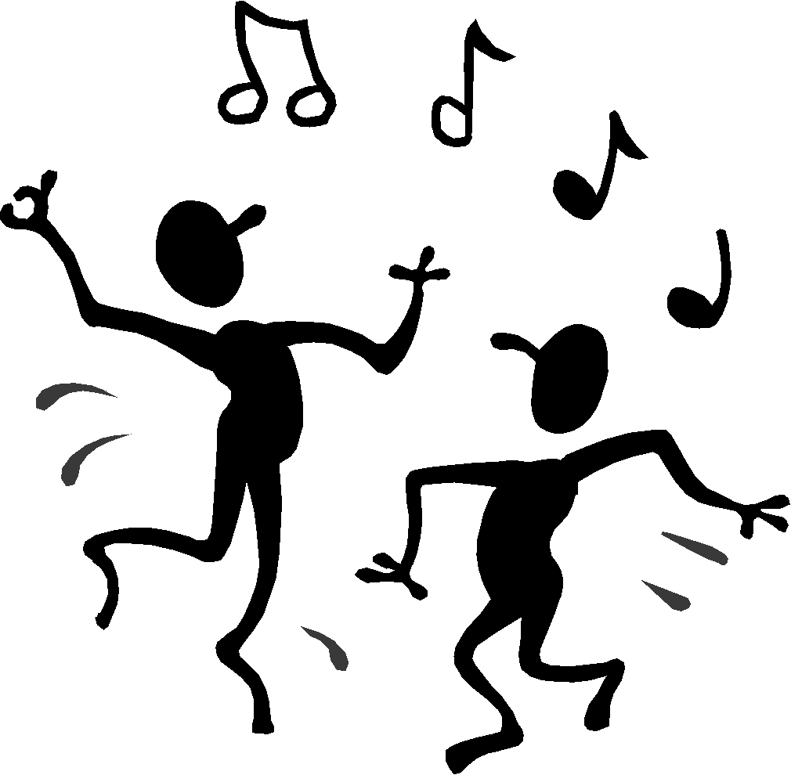

East
North
Task # 17
Task # 18
Task # 16
Task # 14
Task # 11
Task # 12
Task # 13
Task # 9
Task # 8
Task # 7
South
Task # 6
Task # 2
Task # 4
Task # 3
West
Task # 5
Task # 20
Task #15
Task # 10
Task # 19
Task # 1
TASK TRACKER

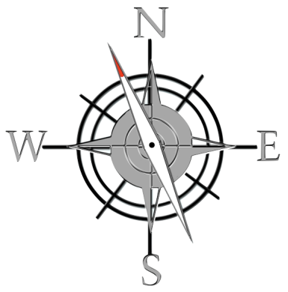

Congratulations!

__________________ has reached the North GPS Marker in the 1st Year Band Program.

_________________________________
Teacher Signature

_________________________________
Principal Signature

Congratulations!

__________________ has reached the East GPS Marker in the 1st Year Band Program.

_________________________________
Teacher Signature

_________________________________
Principal Signature

Congratulations!

__________________ has reached the South GPS Marker in the 1st Year Band Program.

_________________________________
Teacher Signature

_________________________________
Principal Signature

Congratulations!

__________________ has reached the FINAL (West) GPS Marker in the 1st Year Band Program.

You’re done ☺!!

_________________________________
Teacher Signature

_________________________________
Principal Signature

